Maven Cycles Sales Performance Analysis
Dataset: Maven Analytics Bicycle Retail Chain
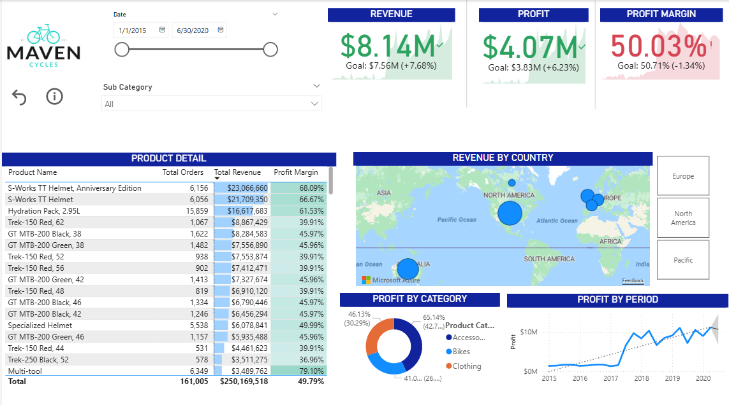

Project Summary
Built a Power BI sales dashboard to analyze revenue, profitability, and regional performance for a multi region bicycle retail chain. The solution covers data cleaning, dimensional modeling, KPI development, secure deployment, and interactive analysis for business stakeholders. Additional screenshots below the report.

Data Preparation
- Cleaned and standardized data using Power Query
- Consolidated multi year sales data
- Created additional columns including price range and aggregated product quantities
- Built a robust Calendar table with year, month, quarter, and time intelligence columns

Data Modeling
- Designed a star schema with Sales as the fact table
- Connected Products, Categories, Subcategories, Calendar, Regions, Gender, and Age Group tables via one-to-many relationships
- Implemented an inactive date relationship to support advanced time analysis
- Ensured single direction filter flow for accurate category filtering

Dashboard & Analysis
- KPI cards for Revenue, Profit, and Profit Margin with conditional formatting
- Interactive slicers for date and product subcategory
- Product-level table showing revenue contribution and margin
- Visual analysis of profit by category, region, and time period
- Drill-through pages for country-level product performance
- Bookmarks for pre-filtered executive views

Deployment & Security
- Published to Power BI Service
- Configured scheduled refresh via data gateway
- Implemented static and dynamic Row Level Security (RLS) by region
- Distributed insights through a published Power BI App

Quantifiable Insights
- Product Concentration Risk
  - The top 20% of products generated ~69% of total revenue, indicating heavy reliance on a small subset of SKUs.
  - Recommendation: protect inventory availability for top performers while diversifying mid-tier product sales.
- Profitability vs. Volume Tradeoff
  - Certain subcategories produced 30 - 40% higher profit margins despite lower unit sales compared to high volume products.
  - Recommendation: prioritize marketing and promotions for high margin categories rather than purely high volume items.
- Regional Performance Gap
  - The region with the lowest profit margin is ~10% lower than the highest performing region.
  - Recommendation: analyze pricing strategy, product mix, and regional demand drivers to close the profitability gap through the promotion of higher profit margin SKUs (accessories).

Skills Demonstrated
- Power Query (data cleaning & transformation)
- Data modeling
- KPI design and profitability analysis
- Time based analysis and drill through
- Power BI Service deployment and governance
- Row Level Security implementation

Screenshots
Price Range Conditional column with formula
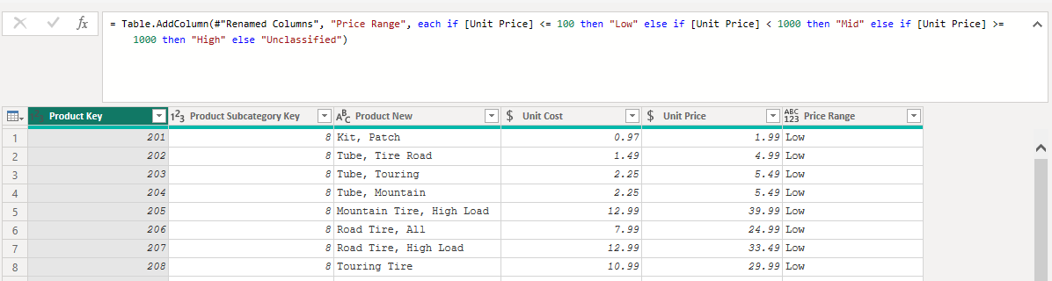
Calendar Table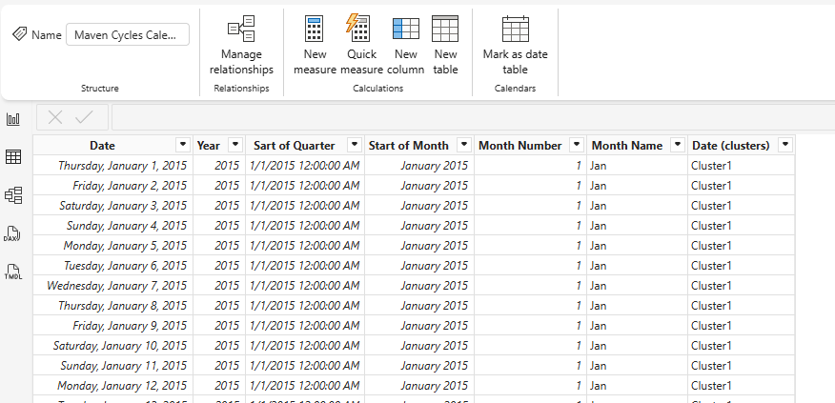

Data Model (star schema)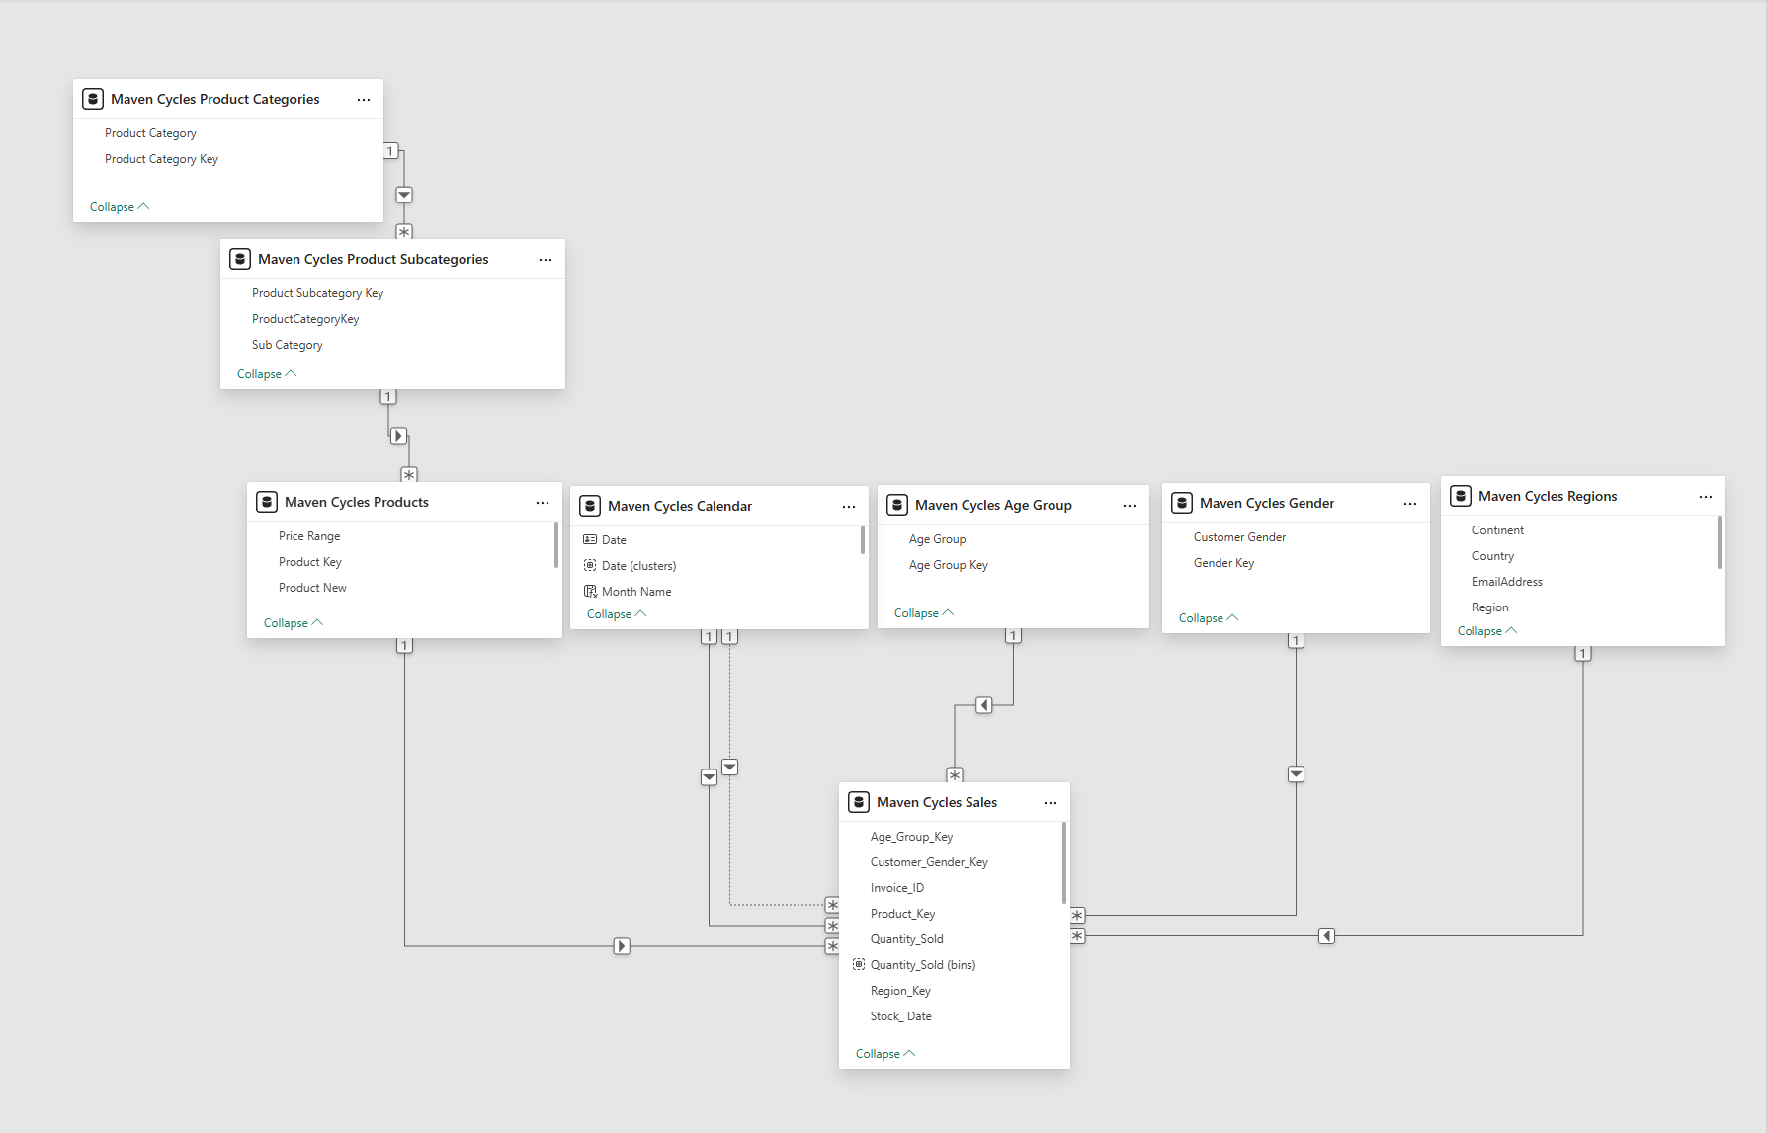
Drill through filtering using Decomposition Tree
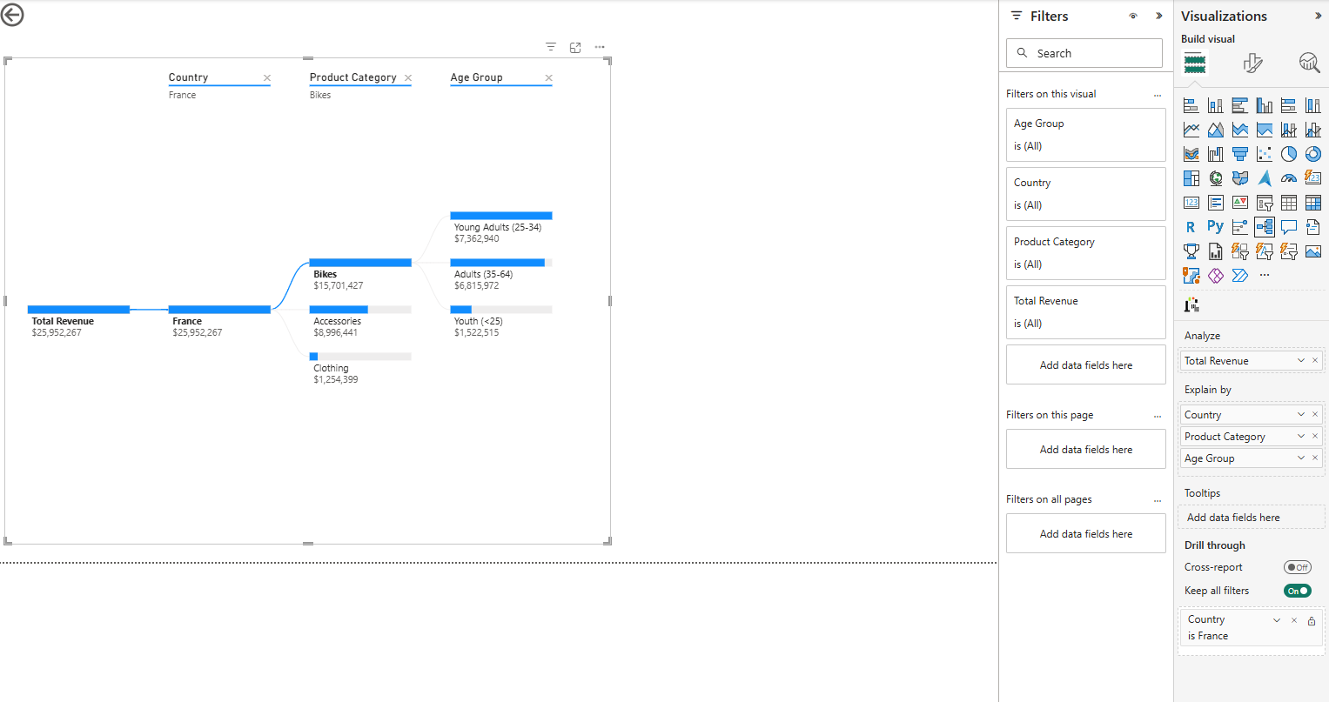
Configured app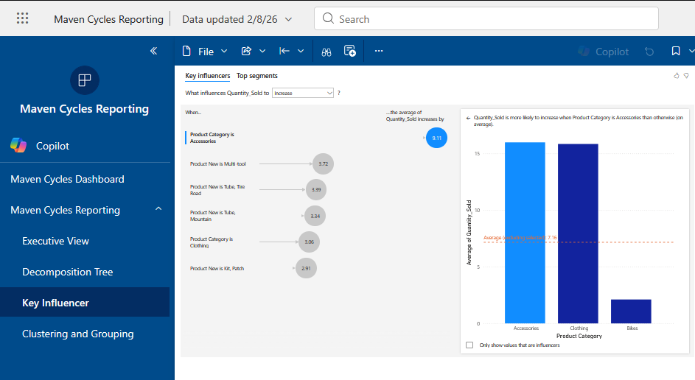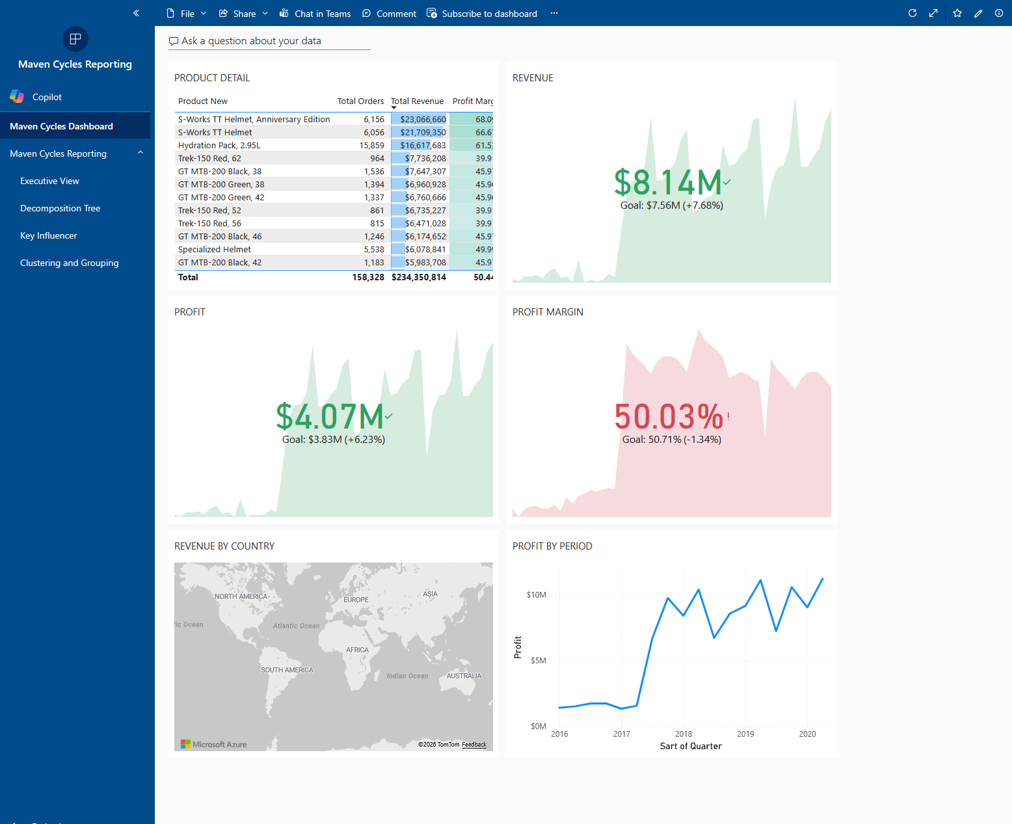

Static RLS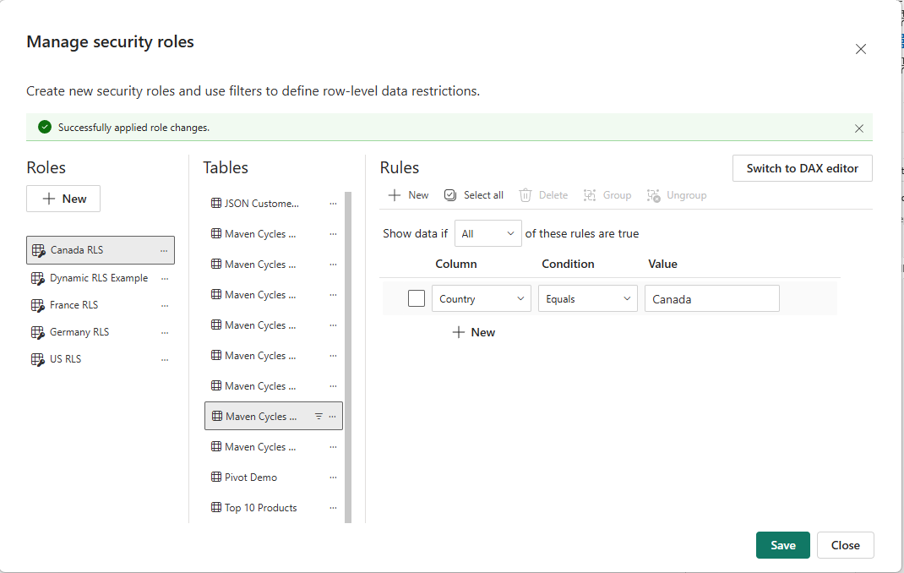
Dynamic RLS